Diabetes Facts for Marion County 2016

Prevalence: People Living with Diabetes
- The prevalence of diabetes in Marion County increased between 2003 and 2014 to 9.8% of adults (over 68,000 cases), but is not statistically different than national or state rates.
- In Marion County, prevalence among African Americans was 69 percent higher than Whites and almost 4 times higher than Hispanic residents during 2014

Diabetes Morbidity:
- Between 2008 and 2013, hospital admission for diabetes mellitus increased from 195.6 cases per 100,000 population to 214 per 100,000 population in Marion County
- Marion County non-trauma lower limb amputations ranged from 34.4 cases per 100,000 population (2008), to 38.1 per 100,000 (2013). Some 60% of non-trauma amputations in the nation are among persons with diabetes.
- In 2013, African Americans in Marion County had 48% higher rate of hospitalizations for diabetes and a 28% higher rate of lower-limb amputations than Whites in Marion County.
- In 2012, the estimated total direct and indirect costs of diabetes in the U.S. was $245 billion including $176 billion for direct medical costs and $69 billion in reduced productivity.

Diabetes Mortality:
- Marion County’s 2014 diabetes age-adjusted mortality rate of 19 deaths per 100,000 is now lower than the rates for Indiana (24.4 per 100,000) and the U.S. (21.2 per 100,000 in 2013).
- Despite a trend of declining mortality rates, diabetes remains the 8th leading cause of death in Marion County (2014) and the 7th leading cause of death nationally (2013).
- In 2014, African Americans were 38% more likely than Whites to die of diabetes (23 per 100,000 versus 16.7 per 100,000 for Whites).

Lifetime Risk of Diabetes for Americans born 2000-2011: Increasing Incidence

The lifetime risk of developing diabetes from age 20 was 40% among Americans born 2000-2011, meaning 2 out of every 5 Americans are expected to develop Type 2 diabetes sometime during adulthood. This is a 13% increase in women and a 20% increase in men since the 1980s.¹ The increase of lifetime risk was mainly due to an increase in incidence of diagnosed diabetes as well as the decline in overall mortality of the general population.¹ Lifetime risk is highest among minorities. Over 55% of non-Hispanic Black women and approximately 1 out of every 2 Hispanic men and women are expected to develop diabetes during their lifetime.¹
Lifetime Risk of diagnosed diabetes, from baseline age, by time period in US adults, 1985-2011¹
Male (%) Female (%)
Overall 40.2 39.6
White, not Hispanic 37.0 34.0
Black, not Hispanic 44.7 55.3
Hispanic 51.8 51.5

From 1980 to 2014, the age-adjusted incidence of diagnosed diabetes among adults in the U.S. aged 18-79 years nearly doubled from 3.5 to 6.6 per 1,000 population (Figure 1). Age-adjusted incidence increased sharply from 3.8 to 8.5 per 1,000 from 1990 to 2008. However, incidence declined significantly from 8.5 to 6.6 per 1,000 between 2008 and 2014.² Diabetes incidence was consistently lower among Whites than among Blacks or Hispanics from 1997 through 2014 (Figure 2). In 2014, the age-adjusted incidence rate among Whites was 6.4 per 1,000 population compared to 8.4 and 8.5 per 1,000 population among Blacks and Hispanics respectively.

Figure 1: Crude and Age-Adjusted Incidence of Diagnosed Diabetes per 1,000 Population Aged 18-79 years, United States, 1980-2014

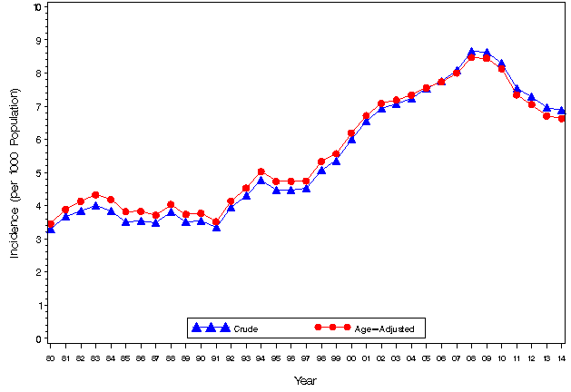

Figure 2: Age-adjusted incidence of diagnosed diabetes per 1,000 population aged 18-79 years, by race/ethnicity, United States, 1997-2014

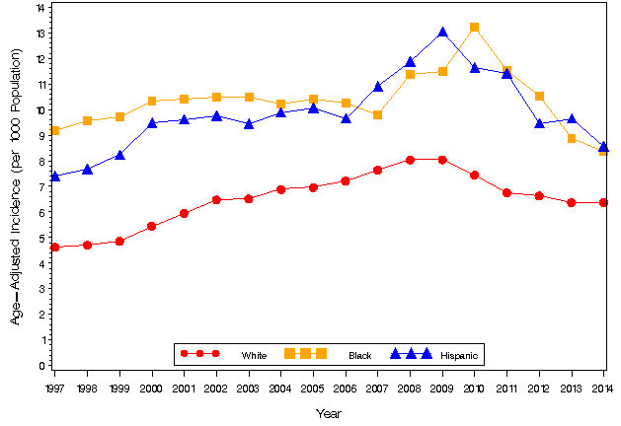

Diabetes Prevalence

The diabetes prevalence rate has been steadily rising for two decades in the United States (
Figure 3), due to both greater incidence, or new cases, in the population, and longer survival of persons with diabetes (affecting the duration of the disease).
In 2014, 9.8% of the adult population in Marion County had been diagnosed with diabetes (Figure 4). A 9.8% estimated diabetes prevalence translates to over 68,000 adults in Marion County who are known to have this disease. However, prevalence in Marion County was not statistically significantly different than recent national or state age-adjusted prevalence rates.

Figure 3: Diabetes Prevalence in Marion County, Indiana, and the U.S.: 1994-2014

Source: Behavioral Risk Factor Surveillance System, 1994-2014; Note: Vertical dotted line indicates major changes made to the survey methods in 2011. State data was unavailable prior to 1999 and county level data was unavailable prior to 2003.

Figure 4: Diabetes prevalence in Marion County, 2003-2014

Source: Behavioral Risk Factor Surveillance System, 1994-2014;DR2851. Note: Vertical dotted line indicates major changes made to the survey methods in 2011.

The CDC’s Behavioral Risk Factor Surveillance System (BRFSS) phone surveys also estimate the prevalence of the different types of diabetes. Marion County figures for diabetes, gestational-onset and pre-diabetes conditions were similar to state and national numbers (Table 1).
Table 1: 2014 Prevalence of Diabetes, Gestational Diabetes, and Pre-Diabetes
 | Diabetes (95% CI) | Gestational Diabetes (95% CI) | Pre-Diabetes (95% CI) | No Diabetes  (95% CI)
Marion County: Total % | 9.8% (8.2-11.5) | 1.8% (0.9-2.6) | 1.1% (0.5-1.6) | 87.2% (85.3-89.2)
Indiana: Total % | 10.7% | 0.8% | 1.0% | 87.5%
U.S.: Median percentage,  50 states | 10.0% (9.7-10.7) | Unavailable | Unavailable | Unavailable
Source: CDC BRFSS survey; Indiana BRFSS Data; DR2851

Diabetes prevalence among Marion County African Americans was 69 percent higher than Whites (Risk Ratio: 1.69), and almost 4 times higher than Hispanic residents (Risk Ratio: 3.84 in 2014 (Table 2). Prevalence was over two times higher among Whites than it was among Hispanics in the county. Diabetes prevalence among Marion County Hispanics and African Americans was not statistically different than the prevalence for the state. However, prevalence among Whites is lower for Marion County than for Indiana. No statistically significant differences are seen in male-to-female comparisons of diabetes prevalence.

Table 2: Diabetes Prevalence in Indiana, and Marion County by Age Group, Race and Gender, 2014
Category | Indiana | Marion County (95% Confidence Interval)
Male | 11.1% | 10.8% (8.1-13.5)
Female | 10.3% | 9.0% (6.9-11.1)
White | 11.1% | 8.9% (7.0-10.8)
Black | 12.2% | 15.0% (10.3-19.7)
Hispanic | 4.8% | 3.9% (2.1-5.6)
Ages: 18-24 | 1.8% | 2.0% (0.0-4.1)
Ages: 25-34 | 2.1%
Ages: 35-44 | 5.2% | 5.4% (3.0-7.8)
Ages: 45-54 | 11.1%
Ages: 55-64 | 18.0% | 23.8% (19.5-28.1)
Ages: 65-74 | 22.3%
Age 75+ | 23.0% | 21.2% (14.7-27.7)
Total | 10.7% | 9.8% (8.2-11.5)
Source: Indiana BRFSS data, ISDH (2014); Marion County BRFSS data (2014) (DR2851). Note: Percentages exclude women that had gestational diabetes only.

Diabetes Complications

Diabetes-related admissions are one of the most common avoidable reasons for hospitalizations in the U.S. The overall Marion County diabetes-related hospitalization rate is 214 admissions per 100,000 population (2013), an increase of 9% since 2008 (195.6 per 100,000) (Figure 5). Marion County rates were similar to the national rate of 206 diabetes-related admissions per 100,000 (2010). Inpatient care for diabetes is significantly higher among minority populations. In Marion County, the rate of diabetes-related hospitalization is 48% higher for African Americans than whites (Table 3).

Diabetes-related Amputations: In 2010, about 73,000 non-traumatic lower-limb amputations were performed in Americans aged 20 years or older with diagnosed diabetes. Marion County rates of non-trauma related lower-limb amputations have increased slightly since 2008 to 38.1 amputations per 100,000 in 2013 (Figure 5). While county discharge data cannot distinguish patients with or without diabetes, national estimates indicate 60% of non-trauma amputations occur in patients with diabetes.⁹ The rate of non-trauma related lower-limb amputations was 28% higher among Marion County Blacks than Marion County Whites in 2013 (Table 3).

Figure 5: Marion County Diabetes-related Hospitalizations and Amputations, 2008-2013.

Source: Marion County hospital discharge data; U.S. Census Data; DR2851; DR1260

Table 3: Marion County diabetes hospitalizations and lower-limb amputations by race, 2013
Race | Diabetes Hospitalizations (per 100,000 population) | Lower-limb Amputations (per 100,000 population)
African American | 268.9 | 51.0
White | 182.3 | 34.7
Total | 214.0 | 39.7
Sources: Marion County hospital discharge data; U.S. Census Data; DR2851

Figure 6: Marion County Diabetes-related Hospitalizations and Total Non-trauma related Amputations, per 100,000 population: 2013.

Sources: Marion County hospital discharge data; U.S. Census Data; DR2851

Diabetes Mortality

Nationally, diabetes ranks as the 7th leading cause of death at 21.2 deaths per 100,000 (2013). However, diabetes may be underreported as a cause of death. ¹¹ The rate of death from all causes is estimated to be about 1.5 times higher among adults aged 18 years or older with diagnosed diabetes than among adults without diagnosed diabetes.
In Marion County, the age-adjusted diabetes mortality rate was 19 per 100,000 population in 2014 which was lower than the rates for Indiana (24.4 per 100,000) and U.S. (21.2 per 100,000) (Table 4). However, diabetes was the 8th leading cause of death for Marion County in 2014 (Table 4). The diabetes mortality rate was almost 40% higher among African Americans than among Whites in the county during 2014 (Table 5). Compared to similar-sized cities, Indianapolis ranks in the middle of the range of diabetes mortality rates seen in cities with population sizes of 500,000 to under 1 million persons.

Table 4: Age-adjusted death rates per 100,000 population for Marion County, Indiana, and the U.S. by cause: 2014
Leading causes of Death in Marion County (ICD-10 code) | Marion County Age-adjusted mortality rate per 100,000 (2014) | Indiana Age-adjusted mortality rate per 100,000 (2014) | U.S. Age-adjusted mortality rate per 100,000 (2013)
Malignant neoplasms  (C00-C97) | 190.2 | 179.4 | 163.2
Diseases of the Heart  (I00-I09,I11,I13,I20-I51) | 176.6 | 181.9 | 169.8
Chronic lower respiratory diseases  (J40-J47) | 60.0 | 54.0 | 42.1
Accidents  (V01–X59,Y85–Y86) | 46.7 | 44.1 | 39.4
Cerebrovascular diseases  (I60-I69) | 40.7 | 41.7 | 36.2
Nephritis, nephrotic syndrome & nephrosis  (N00-N07,N17-N19,N25-N27) | 21.8 | 18.7 | 13.2
Alzheimer’s Disease  (G30) | 21.5 | 29.4 | 23.5
Diabetes mellitus  (E10-E14) | 19.0 | 24.4 | 21.2
Assault (homicide)  (X85-Y09,Y87.1) | 14.9 | 5.7 | 5.2
Intentional Self-Harm  (X60-X84,Y87.0) | 14.0 | 14.2 | 12.6
Overall | 833.6 | 820.4 | 731.9
Source: Marion County Death Records, U.S. Census Data, DR2851; Indiana State Department of Health Mortality Report-2014, Table 5-0; National vital statistics reports, volume 64, no 2.

Table 5: Marion County diabetes mortality rate per 100,000 population by race, 2014
Race/Ethnicity | Diabetes Deaths per 100,000 Population
Hispanic | <5
Black, non-Latino | 23.0
White, non-Latino | 16.7
Source: Marion County Death Records, U.S. Census Data, DR2851

Cost of Diabetes

In 2012, the estimated total cost of diabetes in the United States was $245 billion.⁹ This estimate includes $176 billion for direct medical costs and $69 billion in reduced productivity. ⁹ After adjusting for population age and sex differences, average medical expenditures among people with diagnosed diabetes were 2.3 times higher than what expenditures would be in the absence of diabetes.⁹

Gregg EW, Zhuo X, Cheng YJ, Albright AL, Narayan KM, & Thompson TJ. (2014). Trends in lifetime risk and years of life lost due to diabetes in the USA, 1985-2011: a modeling study. The Lancet Diabetes & Endocrinology, 2(11), 867-874
Centers for Disease Control and Prevention (CDC) (2015, December 1). Diabetes public health resource. Retrieved May 23, 2016, from http://www.cdc.gov/diabetes/statistics/incidence/fig2.htm .
Centers for Disease Control and Prevention (CDC), (2015, December 1). Diabetes public health resource. Retrieved May 23, 2016 from http://www.cdc.gov/diabetes/statistics/incidence/fig6.htm
Centers for Disease Control and Prevention (CDC). (2012, November 16). Increasing prevalence of diagnosed diabetes – United States and Puerto Rico, 1995-2010. MMWR. Morbidity and Mortality Weekly Reports. Retrieved from http://www.cdc.gov/mmwr/preview/mmwrhtml/mm6145a4.htm
Nationally, 12 percent of all admissions have been attributed to Ambulatory Care Sensitive (ACS), including uncontrolled diabetes, pneumonia, congestive heart failure, and asthma. Ambulatory care sensitive (ACS) conditions are conditions for which hospitalizations may be prevented by appropriate access to primary care. [Pappas G, Hadden WC, Kozak LJ, Fisher GF. Potentially avoidable hospitalizations: inequalities in rates between U.S. socioeconomic groups. Am J Public Health, 1997; 87(5): 811–816. ]
Diabetes-related hospitalizations are any which include diabetes in the discharge diagnoses fields. Hospital discharge data does not distinguish between patients with and without diabetes. These rates are not restricted to only patients with diabetes.
National Center for Health Statistics (NCHS). (2015). National hospital discharge survey. Retrieved from http://www.cdc.gov/nchs/data/nhds/2average/2010ave2_firstlist.pdf.
Jiang HJ, Andrews R, Stryer, D, and Friedman B, 2005. Racial/ethnic disparities in potentially preventable readmissions: The case of diabetes. American Journal of Public Health, 95(9), 1561-1567.
American Diabetes Association. (2016). Statistics about diabetes. Retrieved from http://www.diabetes.org/diabetes-basics/statistics/.
Xu JQ, Murphy SL, Kochanek KD, Bastian BA, 2016. Deaths: Final data for 2013. National vital statistics reports, 64(2).
Centers for Disease Control and Prevention (CDC). (2014). National diabetes statistics report: Estimates of diabetes and its burden in the United States, 2014. Retrieved from http://www.cdc.gov/diabetes/pubs/statsreport14/national-diabetes-report-web.pdf.
National Association of County and City Health Officials, 2007. Big cities health inventory: The health of urban America, 2007. Table 3.19

